Our 2021 Thanksgiving at Dave & Michelle’s New Home in Stow, MA.

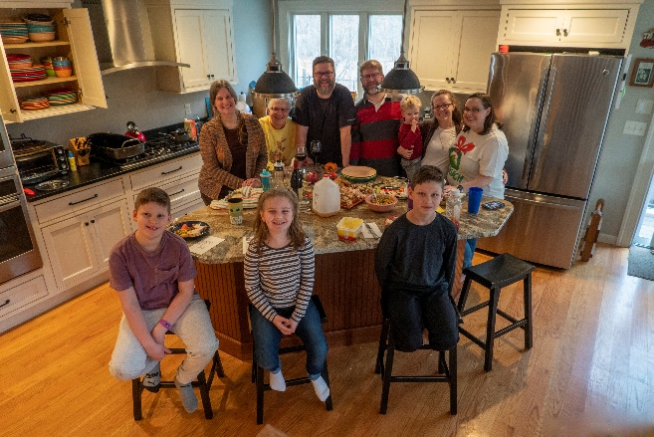Thanksgiving Day is our annual holiday commemorating the harvest festival celebrated by the Pilgrims in 1621 and is held in our country on the fourth Thursday in November.

Our family members gathered at Dave & Michelle’s spiffy new home in Stow. We all enjoyed Dave & Michelle’s wonderful hospitality at their first Thanksgiving as we celebrated the day. Each of the families brought plenty of festive foods to share - all approved by our cardiologists of course. Jen’s husband, Dan, was celebrating with his family in West Virginia.

And for the photos, click [2021 Thanksgiving](https://photos.app.goo.gl/yEF9goE581jx5a479). You are encouraged to “Zoom”.